Project Development Phase
Performance Test
Date | 30 September 2026
Team ID / Project ID | SWTID-2026-8678
Project Name | Script-Controlled ACL – Restrict Record Access Based on Field Value
Maximum Marks | 10 Marks

ACL Performance Testing:
Project team shall fill the following information in the performance testing template.
S.No. | Parameter | Screenshot / Values
1 | Data / Records Created | Multiple records created in u_institution_details with different Branch values: ECE, EEE and CSE. 
2 | Access Control Configuration | Record-level ACLs configured for Read, Create, Write and Delete operations using roles bb1, bb2, bb3 and bb4.  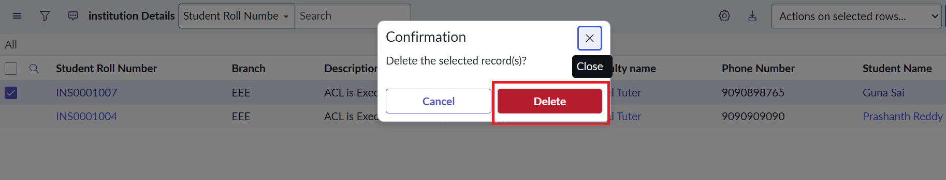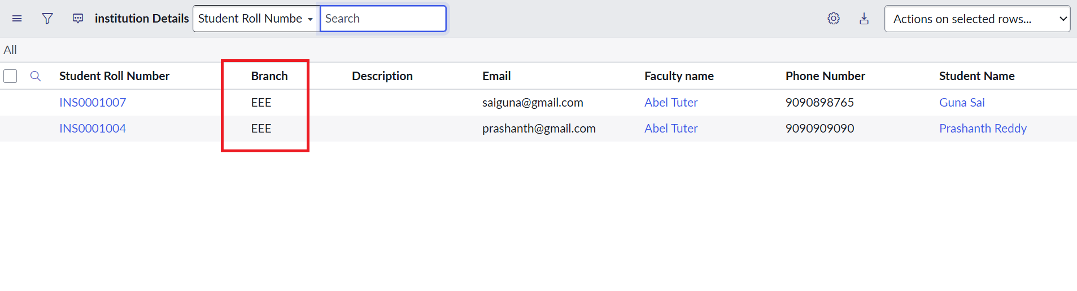
3 | Utilization of Access Conditions | Read access uses the EEE branch condition. Admin users retain full access. Users without the required role are denied access.  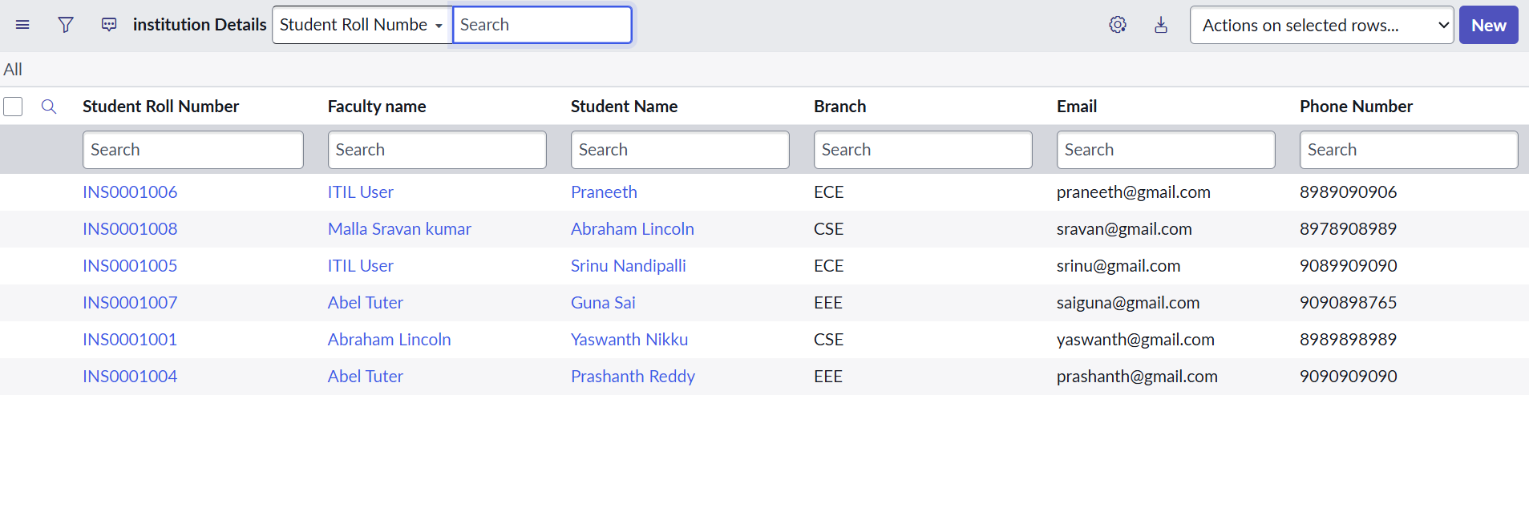
4 | Script / Rules Used | Read ACL script checks admin access, checks the bb1 role, and denies access for other users. Create, Write and Delete ACLs use the corresponding custom roles.
5 | List / Form Access Design | Access verified through the Institution Details list and record forms using user impersonation. Screenshots of authorized and unauthorized access to be attached.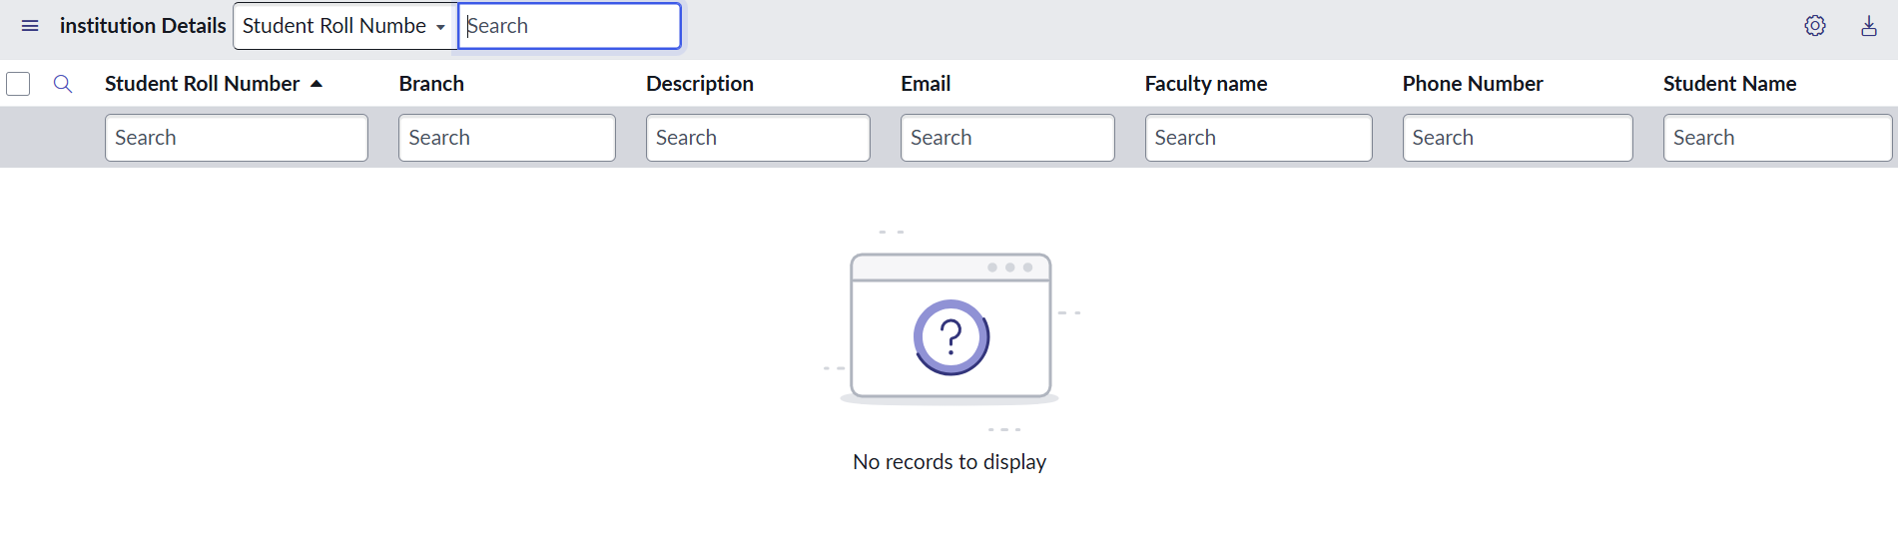
6 | Verification / Test Design | Verify bb1 users can view EEE records; bb1+bb2 can create; bb1+bb2+bb3 can edit; bb1+bb2+bb3+bb4 can delete; Admin can access all records.

Expected Outcome:
The ServiceNow Script-Controlled ACL implementation should enforce record-level security according to the configured roles and EEE branch condition, while administrators retain full access.

